### 

### Semester Two Examination, 2022

### Question/Answer booklet

# MATHEMATICS SPECIALIST

**UNITs 3&4**

## Section One:

## Calculator-free

|  |
| --- |
|  |

Your Name

Your Teacher’s Name

## Time allowed for this section

Reading time before commencing work: five minutes

Working time: fifty minutes

## Materials required/recommended for this section

***To be provided by the supervisor***

This Question/Answer booklet

Formula sheet

***To be provided by the candidate***

Standard items: pens (blue/black preferred), pencils (including coloured), sharpener, correction fluid/tape, eraser, ruler, highlighters

Special items: nil

## Important note to candidates

No other items may be taken into the examination room. It is **your** responsibility to ensure that you do not have any unauthorised material. If you have any unauthorised material with you, hand it to the supervisor **before** reading any further.

|  |  |  |  |  |  |
| --- | --- | --- | --- | --- | --- |
| Question | Mark | Max | Question | Mark | Max |
| 1 |  |  | 5 |  |  |
| 2 |  |  | 6 |  |  |
| 3 |  |  | 7 |  |  |
| 4 |  |  | 8 |  |  |

**Structure of this paper**

|  |  |  |  |  |  |
| --- | --- | --- | --- | --- | --- |
| Section | Number of questions available | Number of questions to be answered | Working time (minutes) | Marks available | Percentage of examination |
| Section One:  Calculator-free | 8 | 8 | 50 | 49 | 35 |
| Section Two:  Calculator-assumed | 14 | 14 | 100 | 97 | 65 |
|  |  |  |  | **Total** | 100 |

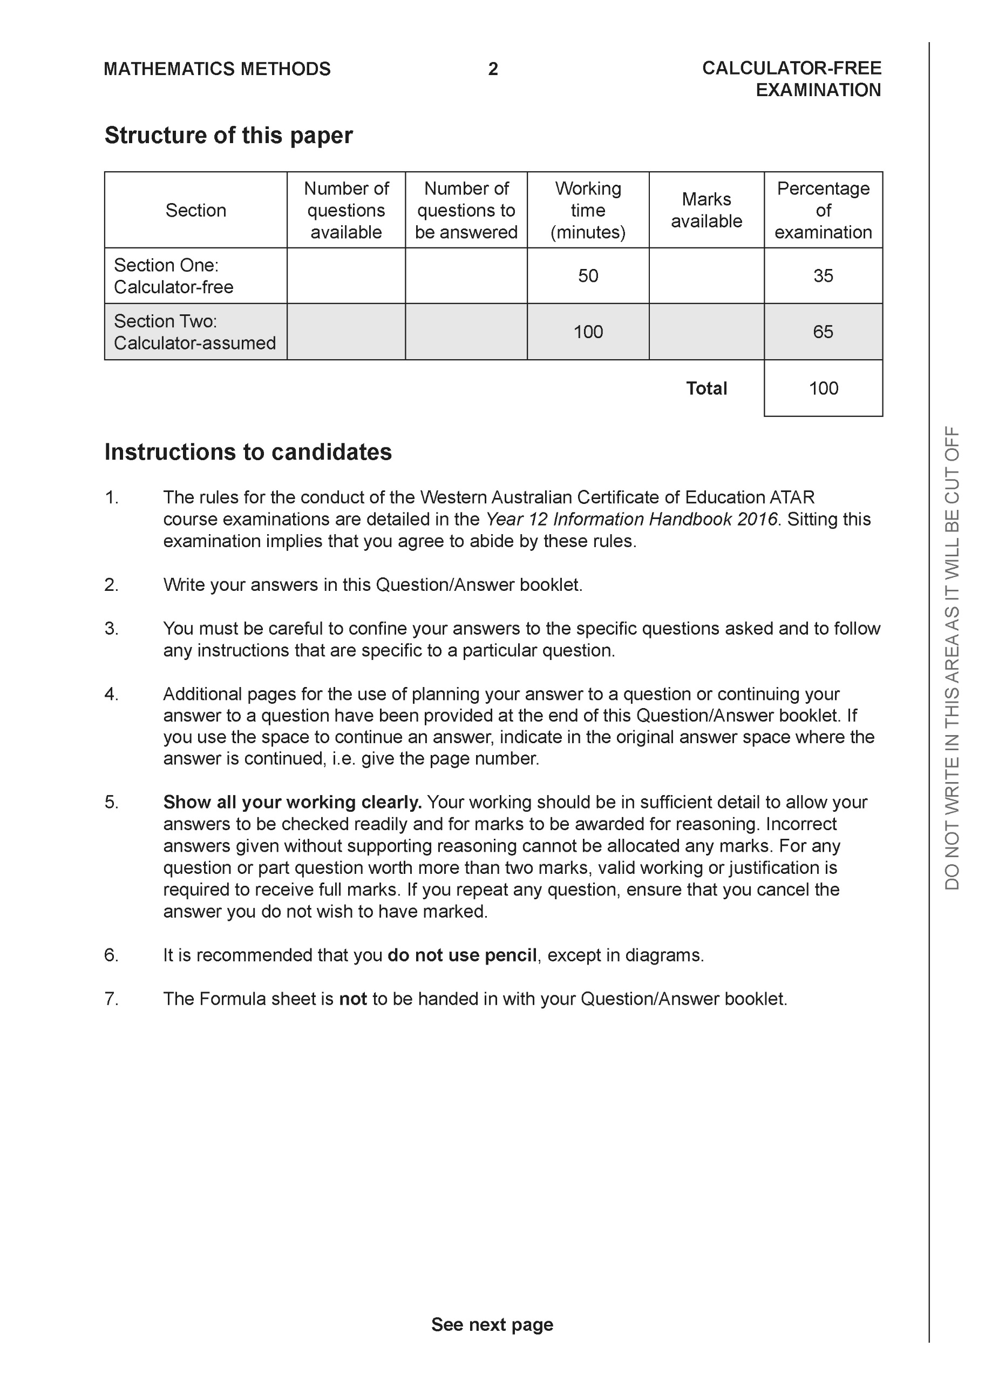

**Section One: Calculator-free (49 Marks)**

This section has 8 questions. Answer **all** questions. Write your answers in the spaces provided.

Spare pages are included at the end of this booklet. They can be used for planning your responses and/or as additional space if required to continue an answer.

● Planning: If you use the spare pages for planning, indicate this clearly at the top of the page.

● Continuing an answer: If you need to use the space to continue an answer, indicate in the original answer space where the answer is continued, i.e. give the page number. Fill in the number of the question that you are continuing to answer at the top of the page.

Working time: 50 minutes.

**Question 1 (5 marks)**

Consider the complex numbers  and  which are plotted below.

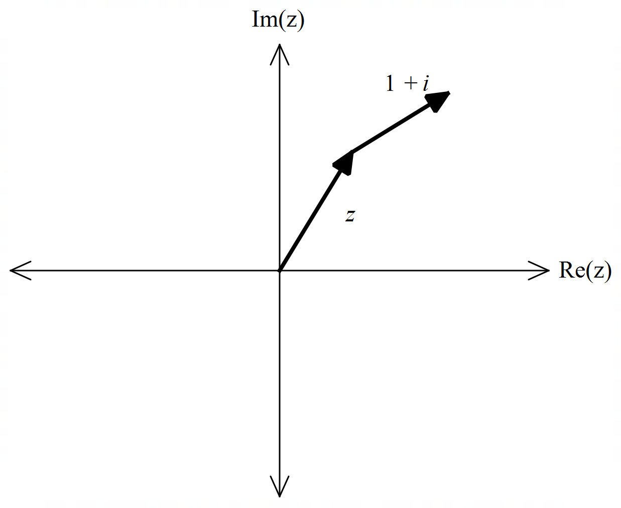

1. Express  in polar form. (1 mark)

|  |
| --- |
| **Solution** |
|  |
| **Specific behaviours** |
| 🗸 states polar form |

1. Determine an exact expression for  . (4 marks)

|  |
| --- |
| **Solution** |
|  |
| **Specific behaviours** |
| 🗸 uses triangle with angles stated as above  🗸 uses cosine rule with correct lengths  🗸 evaluates cos 150  🗸 states exact answer as above without cosine |

**Question 2 (13 marks)**

Consider the two functions  as shown below.

|  |  |
| --- | --- |
|  |  |

1. Sketch the inverse of  on the same set of axes. (2 marks)

|  |
| --- |
| **Solution** |
|  |
| **Specific behaviours** |
| 🗸 reflected in y=x  🗸 both endpoints correct |

1. Explain why  does not have an inverse. (1 mark)

|  |
| --- |
| **Solution** |
| Many to one function |
| **Specific behaviours** |
| 🗸 states reason |

The defining rule for  is as follows 

1. Determine the rule for  and state its domain. (3 marks)

|  |
| --- |
| **Solution** |
|  |
| **Specific behaviours** |
| 🗸 swaps variables or solves for x  🗸 states inverse rule  🗸 states domain |

1. Determine . (2 marks)

|  |
| --- |
| **Solution** |
|  |
| **Specific behaviours** |
| 🗸 uses g(0)  🗸 states final result |

1. Does  exist for all values of the natural domain of ? Explain. (2 marks)

|  |
| --- |
| **Solution** |
|  |
| **Specific behaviours** |
| 🗸 states relevant domain and range  🗸 states no with a reason |

1. Determine the domain and range of . Justify. (3 marks)

|  |
| --- |
| **Solution** |
|  |
| **Specific behaviours** |
| 🗸 uses domain of f  🗸 states range of f  🗸 states range of gof |

**Question 3 (5 marks)**

Using an appropriate substitution, determine the following integral .

|  |
| --- |
| **Solution** |
|  |
| **Specific behaviours** |
| 🗸 defines a subs variable u  🗸 changes integral from dx to du  🗸 changes limits to u values  🗸 integrates expression  🗸obtains a value for integral in terms of surds |

**Question 4 (5 marks)**

Consider the function . Sketch the function on the axes below showing all asymptotes and major features.

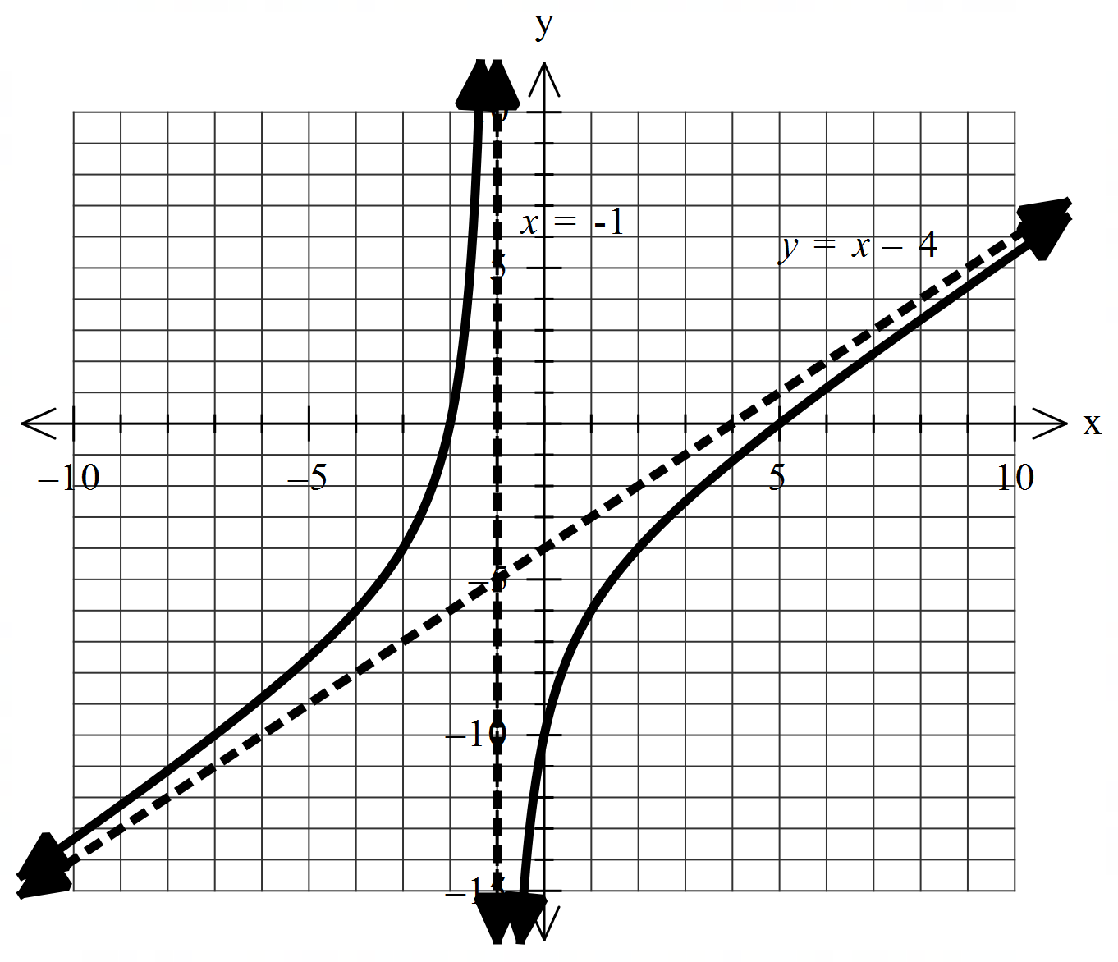

|  |
| --- |
| **Solution** |
|  |
| **Specific behaviours** |
| 🗸 shows and labels vertical asymptote  🗸 shows and labels oblique asymptote ( accept y=x)  🗸 x intercepts correct  🗸 y intercept correct  🗸 shape is correct |

**Question 5 (6 marks)**

1. Given that  , determine the values of the constants . (3 marks)

|  |
| --- |
| **Solution** |
|  |
| **Specific behaviours** |
| 🗸 sets up quadratic equation with three constants  🗸 solves for a  🗸 solves for b & c |

1. Hence determine   and express answer as one log term. (3 marks)

|  |
| --- |
| **Solution** |
|  |
| **Specific behaviours** |
| 🗸 integrates all terms  🗸 subs limits and subtracts  🗸 expresses as one log term |

**Question 6 (5 marks)**

Consider the polynomial  with .

1. Determine a quadratic factor of . (2 marks)

|  |
| --- |
| **Solution** |
|  |
| **Specific behaviours** |
| 🗸 uses conjugate  🗸 states quadratic factor |

1. Hence solve the equation  (3 marks)

|  |
| --- |
| **Solution** |
|  |
| **Specific behaviours** |
| 🗸 solves for second quadratic factor  🗸 uses quadratic equation  🗸 states all four roots |

**Question 7 (5 marks)**

By using  and De Moivre’s theorem, determine exact values for .

|  |
| --- |
| **Solution** |
|  |
| **Specific behaviours** |
| 🗸 sets up equation to find cartesian roots  🗸 determines polar square roots  🗸 solves for a & b  🗸 equates real and imaginary parts of both forms of roots  🗸 states exact surd expressions for cosine and sine |

**Question 8 (5 marks)**

Determine the integral  showing full working.

|  |
| --- |
| **Solution** |
|  |
| **Specific behaviours** |
| 🗸 takes out one sin expression  🗸 uses Pythagorean to convert rest to cos functions  🗸 expands brackets into 3 terms  🗸 integrates all terms by adding one to cosine power  🗸determines all correct factors (no need for plus constant) |

Working out space